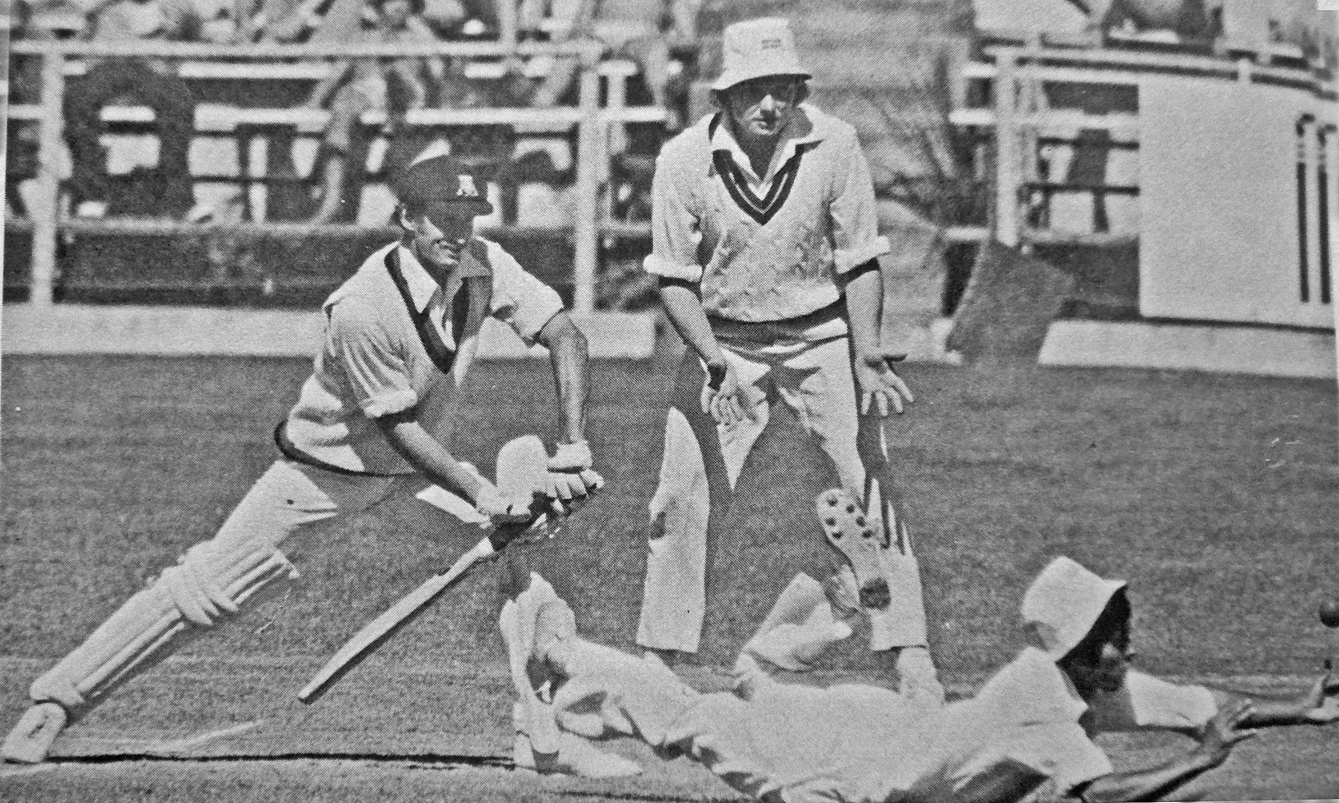

**Dayle Hadlee missed by Kirti Puna**

**Canterbury v Northern Districts 3 January 1978 Lancaster Park**

**Canterbury 256/8 and 219. Northern Districts 289/6 declared and 39/2 Match drawn**